**BANASD602 Visual Analytics and Storytelling**

**Case Study Report – Industry- Based Work Project**

**Assessment 2**

***Presented By: Tanya Khadka***

***Student ID: A00138967***

***Date: 20/04/2025***

***Presented For: Mr. Tirtha Raj Bhandari***

**Table of Content**

**Introduction………………………………………………………………………………………………………………………………4**

**Dataset………………………………………………………………………………………………………………………………………4**

**Data Review and Data Cleaning………………………………………………………………………………………………….4**

**Findings from Data Exploration and Analysis………………………………………………………………………………………………………………………………….5-7**

**Conclusion………………………………………………………………………………………………………………………………….7**

**References………………………………………………………………………………………………………………….……………..8**

**Academic Integrity Declaration**

I declare that except where I have referenced, the work I am are submitting in this attachment is my own work. I have read and am aware of Torrens University Australia Academic Integrity Policy and Procedure viewable online at <http://www.torrens.edu.au/policies-and-forms>. I am aware that I need to keep a copy of all submitted material and their drafts, and I/we will do so accordingly.

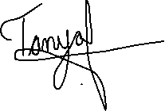

**Tableau Workbook-Draft-Refer to Rubrics**

**Step 1: Review the data**

1. Consider feedback received in Assessment 1 on your proposed dataset.

**Step 2: Connect to and prepare data (see Module 2.2)**

Connect your dataset selected in Step 1 to Tableau software and prepare the dataset as follows (where appropriate):

1. Clean the data
2. Check for errors, missing values, or outliers and reload data in Tableau
3. Manage data properties (e.g., rename data fields and change data types)
4. Add relations, joins, and unions.

**Step 3: Explore and analyse the data (see Module 3.1)**

* 1. Create visualisation charts to address at least five (5) investigative questions (address the questions you identified in Assessment 1; if an alternative dataset was selected in Step 1, create charts to address at least five (5) new investigative questions).

1. Include proper legends and labels for the axis
2. Produce a proper heading for the Tableau worksheets
3. Use a consistent colour scheme.

**Case Report-Draft-Refer to Rubric**

**Introduction (50-100)**

**Dataset (150-200)**

* Provide a link to the dataset
* Provide an overview of the dataset and rationale for your choice

**Data Review and Data Cleaning (150-200)**

* Document your data review and cleaning process (outcomes from Step 2)

**Findings from data exploration and analysis (450-500)**

* Identify the target audience for the analysis and their interests.
* Explain your investigative questions and include screenshots of Tableau charts created to address each question.
* Document the suitability of each chart by considering and expanding upon the following questions:
* What is the key message of the data?
* What is each chart’s relevance to addressing investigative questions?

**Conclusion (50-100)**

* + Summarise the findings, limitations, and recommendations for future analysis.

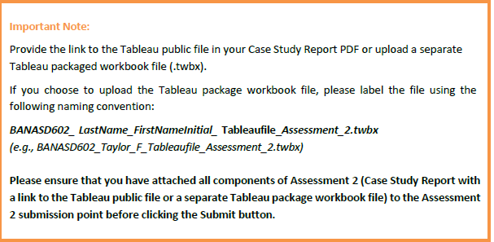

**References**

Questions to Ask

1. Research Questions
2. Comment for qst 4 is not visible
3. There’s a comment after conclusion but I am not sure abt it.
4. I asked extension which has been approved in email but not in MyLearn
5. Can I change my research questions instead of Dataset
6. We had issue extracting the Tableu Workbook .twbx, has that been resolved as I was not in the class last week.